HW 5.1

TU23FL-CAD

Dr. Laura Riggio

Jakob Werle

2023-10-22

Contents

Introduction 2

Procedure 2

Results 4

Discussion 6

# Introduction

A solid element simulation will be created for a simple cantilever bracket and will be simulated with given fixtures and loads applied. The simulation results for stress will then be compared to theoretical calculations.

Figure 1 Cantilever Bracket Drawing

The above drawing depicts the model dimensions and constraints.

# Procedure

A cantilever bracket SOLIDWORKS part model from the CAD textbook was used to create a solid element model. First, a static simulation was create. Next, the left side of the bracket was fixed while a split line on the right side of the bracket had a 6500N tensile force applied to it. A standard, high quality mesh was created and checked over for irregularities.

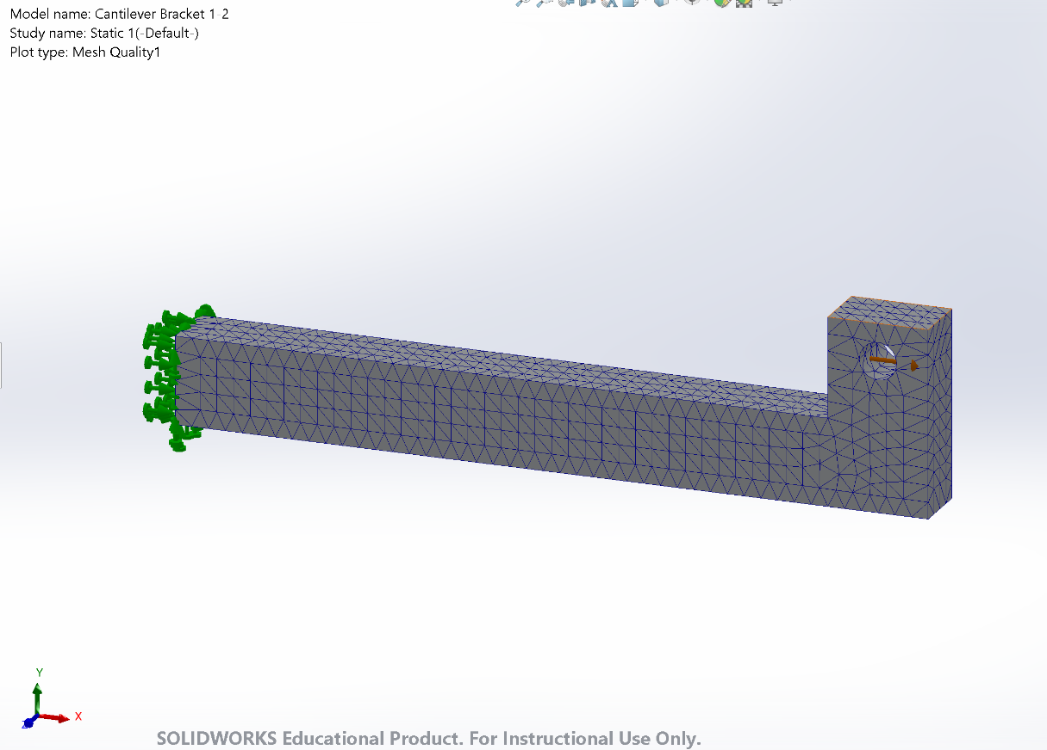

Figure 2 Solid Element Model

Figure 2 shows the SOLIDWORKS simulation constraints and mesh results.

The simulation was ran and then contour plots were setup to display stress. The stress was probed along the nodes and element midpoints roughly 50mm from the left face of the bracket (Section A-A).

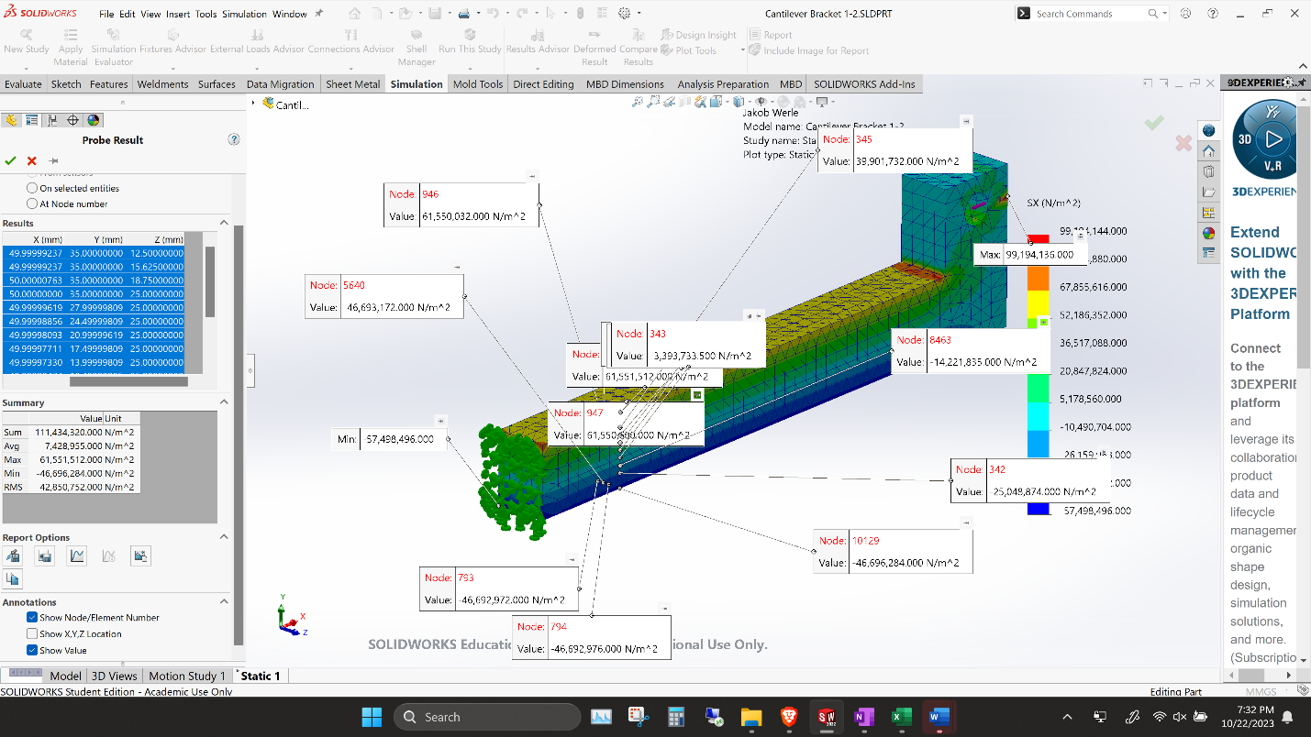

Figure 3 Probing Section A-A

Figure 3 displays the process of probing points at Section A-A and recording their values.

# Results

Figure 4 Theoretical Hand Calculations

Figure 4 goes through the hand calculations to solve for the stress at the top, centroid, and bottom of the bracket at Section A-A.

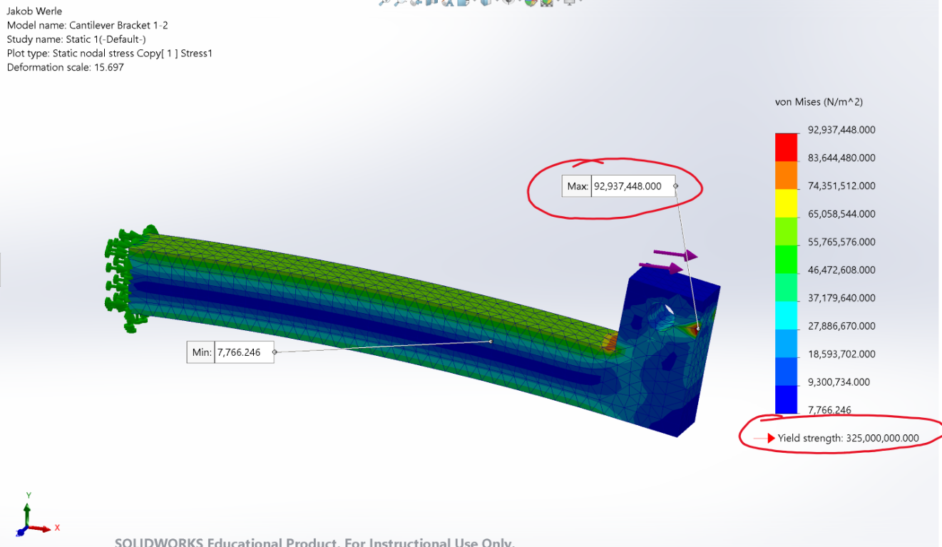

Figure 5 von Mises Stress Contour Plot

Figure 5 displays the contour plot for von Mises stress. Maximum endured stress and material yield stress are highlighted for further discussion.

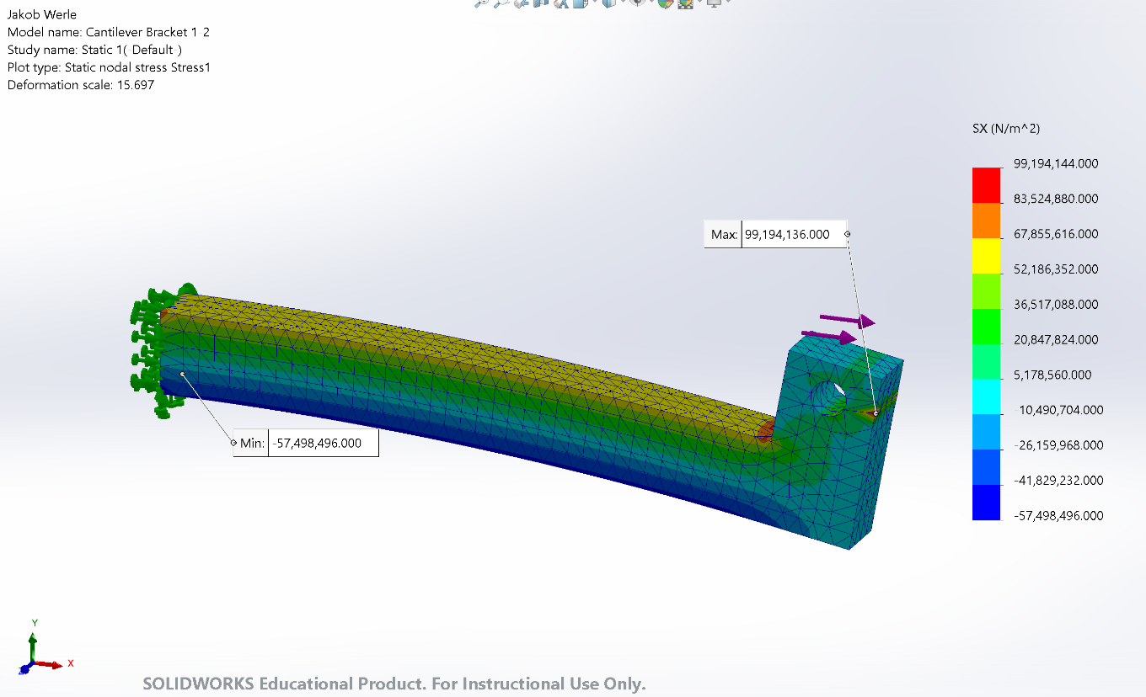

Figure 6 Stress - X Contour Plot

Figure 6 shows the contour plot for stress in the X direction.

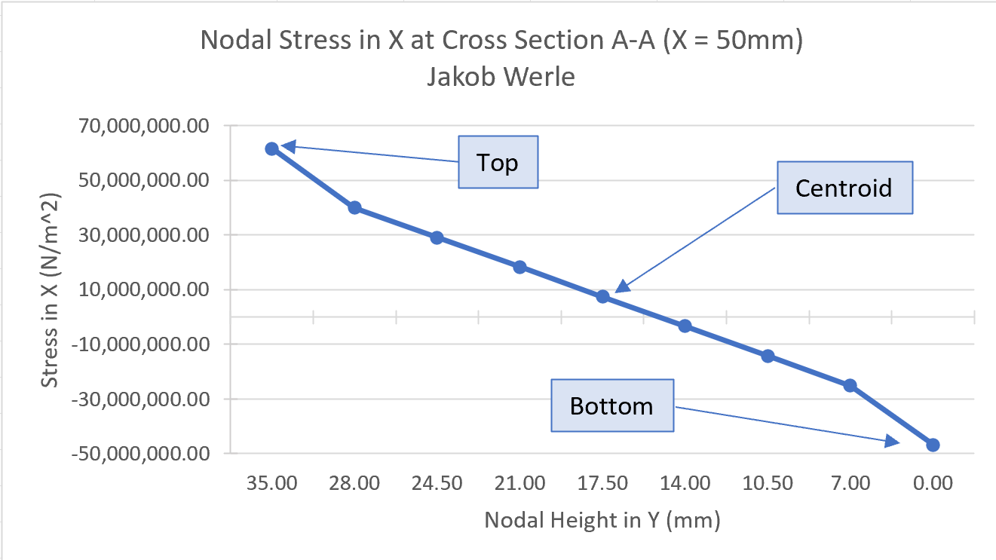

Figure 7 Stress vs Y Position Graph

Figure 7 is a graph that plots the stress in the X direction against the height of each node in the Y direction at Section A-A. Shear stress in noted at the top, centroid, and bottom of the bracket’s cross section.

Table 1 Results Comparison

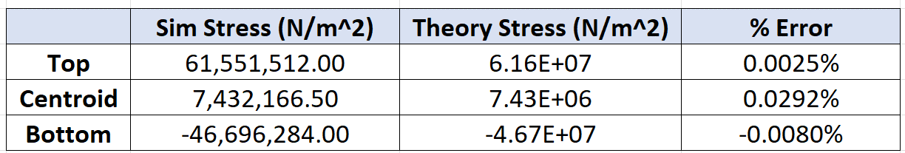

Table 1 displays the percent error between simulation and hand calculated results for stress and the top, center, and bottom of the bracket.

# Discussion

The calculated top, centroid, and bottom stress can be seen in Figure 4. Simulated results for the same stresses can be found in Figure 7, plotted against their vertical position. As seen in Table 1, the margin of error between hand calculations and simulation results is less than 0.1% for all locations which signifies a relatively accurate solid element model. The small errors that did occur could be results of rounding errors in hand calculations or slight locational deviance while probing simulation results.

With the confirmation that the simulation model is functional, is can be said that the part would not fail since the largest stress did not exceed the yield strength of the material, as witnessed in Figure 5. Even with a simple standard mesh, SOLIDWORKS simulation proved to be a reliable tool for this analysis. Further refinement of the mesh could result in more accurate results if more analysis was required.